

**YEAR: 8**

**2016**

**SUBJECT: Science**

**Test: Microscopes**

**TIME: 50 minutes**

**QUESTIONS: Section A: 12 Multiple Choice (12marks)**

**Section B: 4 Short Answer (18 marks)**

**Section C: 2 Long Answer (10 marks)**

**TOTAL MARKS: 42 marks**

**PLEASE DO NOT WRITE ON THIS BOOKLET**

**SECTION A: Multiple Choice Questions**  
*This section has 12 questions. Answer all questions on the separate multiple-choice answer sheet provided.*

1. The smallest unit of life is..
2. cell
3. tissue
4. atom
5. organ
6. The magnification of the microscope tells you

a) how big the lenses in the microscope are

b) how much smaller the image is than the real object

c) how much bigger the image is than the real object

d) how much light is passing through the object

1. Which of the following is the smallest unit of length?

a) Micrometers

b) Kilometers

c) Millimeters

d) Centimeters

1. A micrometre (μm) is:

a) one-thousandth of a millimetre   
b) one-hundredth of a millimetre   
c) one-thousandth of a centimetre  
d) one-hundredth of a centimetre

1. Which cell structure allows substances to enter and leave the cell?

a) cytoplasm

b) cell membrane

c) nucleus

d) vacuole

1. The main benefit of staining is…
2. Increasing the size of cells, making them easier to see
3. Slows down movement of living cells, making them easier to see
4. Improves the contrast, making the cell and its features stand out more
5. Improve the colour, making it more interesting
6. When carrying a microscope, what is the safest part to hold?
7. stage
8. arm
9. mirror
10. tube
11. Which of the following is **NOT** a part of animal cells?
12. nucleus
13. cell wall
14. cytoplasm
15. cell membrane
16. What is the definition of a unicellular organism?
17. a living thing
18. a single celled living thing
19. more than one cell living thing
20. a non-living thing
21. What is the purpose of the cell wall in plant cells?
22. allow nutrients in and out of the cell
23. hold the organelles of the cell
24. provide structure and support to the cell
25. allows the cell to photosynthesise
26. What does a plant cell have that an animal cell does not?
27. cytoplasm
28. chloroplast
29. nucleus
30. cell membrane
31. Mitochondria, ribosomes, lysosomes and endoplasmic reticulum are examples of

a) organelles

b) chloroplast

c) muscles

d) nuclear membrane

**Safety Bay Senior High School**

**Science 8 – Microscope Test**

Name: _______________________________________________

Section A: Multiple Choice Answers

Put a cross (X) through the correct answer.

**1** a b c d

**2** a b c d

**3** a b c d

**4** a b c d

**5** a b c d

**6** a b c d

**7** a b c d

**8** a b c d

**9** a b c d

**10** a b c d

**11** a b c d

**12** a b c d

Marks

Section A: Section B: Section C:

Multiple Choice Short Answers Long Answer Total

/42

/18

/10

/12

**Short Answer Section**

13) Label and describe the function of each part in the boxes below. (7 marks)

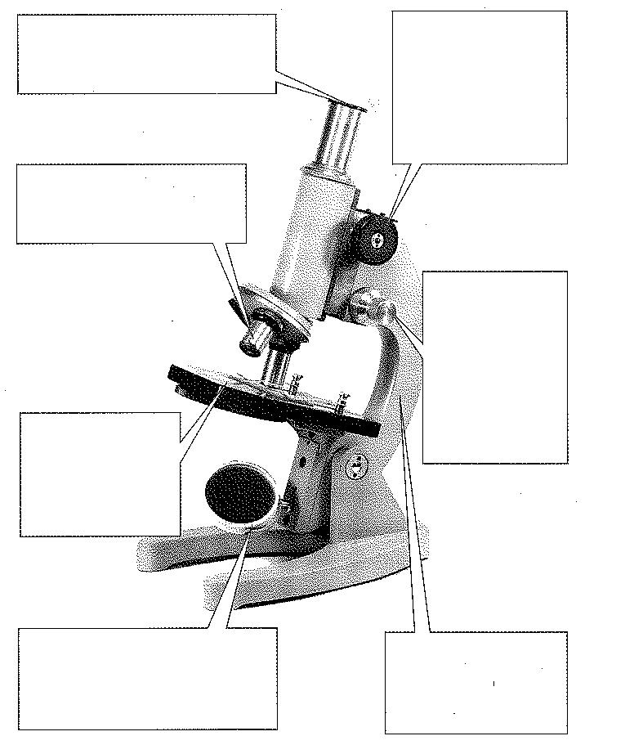

Arm (0.5)

To carry microscope (0.5)

Mirror (0.5)

Direct light through stage/specimen (0.5)

Stage (0.5)

Where specimen is placed (0.5)

Objective lens (0.5)

Magnifies the image (0.5)

Occular lens/Eyepiece (0.5)

Magnifies the image (0.5)

Large/ course focus /adjustment knob (0.5)

Focus the image on low power (0.5)

Fine focus/ adjustment knob (0.5)

Focus the image on high power (0.5)

14. Complete the following: (2 marks)

a) Name two microscope parts that magnify the slide  
  
Eye piece/ocular lens (0.5) + Objective lens (0.5)

b) Name two microscope parts that allows a slide to be focused  
  
Coarse adjustment/focus (0.5) + Fine adjustment/focus (0.5)

15. Use the diagram to complete the following questions

1. Label the diagram using the following; (5 marks)

**ribosomes, mitochondria, nucleus, cell membrane, cytoplasm**

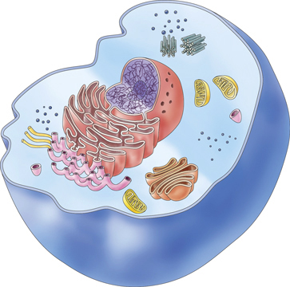

Nucleus

Ribosomes

Cytoplasm

Mitochondria

Cell membrane

1. Is the diagram of a plant or animal cell? Explain? (2 marks)

Animal (1)

No cell wall/No chloroplasts/No large vacuole (Any two for 1 mark)

16. Describe the function of the following organelles: (2 marks)

Ribosomes

Where proteins are made (1)

Chloroplasts

Where photosynthesis occurs (1)

**SECTION THREE: Long Answer**

17. Describe the similarities and differences between animal and plant cells (6 marks)

|  |  |
| --- | --- |
| *Similarities* | *Differences* |
| Both have mitochondria (1) | Plants have chloroplasts (1) |
| Both have cell membrane (1) | Plants have cell wall (1) |
| Both have nucleus (1) | Plants have large vacuole (1) |

18. Suggest why the cells in a multicellular organism are not all the same.   
Give examples in your answer. (4 marks)

|  |
| --- |
| Different cells need to carry out different functions (1) |
| Cells have different structures to complete different functions (1) |
| Naming an example: eg. Red blood cells, muscle cells, nerve cells (1) |
| Use example to explain structure. eg. Red blood cells have large surface area to carry more oxygen (1) |